Nama : Nayottama Satya Hutama

NIM : 18090004

Kelas : 5C

PRAKTIKUM 4

1. Source code

Web.php => controller

v_header.php => View

v_footer.php => View

v_index.php => View

v_about.php => View

stylebuku.css => assets/css

1. URL

<http://localhost/Pustaka_Booking_Nayottama/Web>

<http://localhost/Pustaka_Booking_Nayottama/Web/about>

1. Capture Output Program

Web

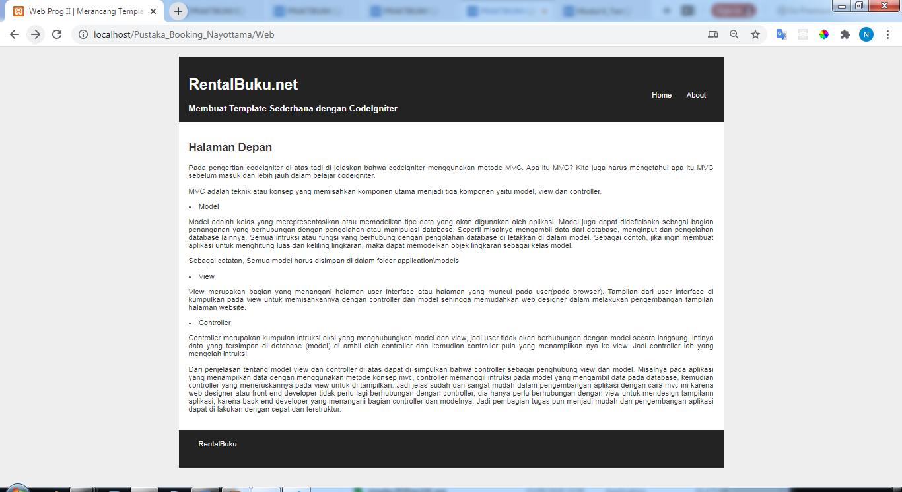

About

